Methods
The current study is interested in the question: “Do economic factors influence the likelihood of an offender choosing to commit a residential burglary?” Based on the current literature on this topic, which was previously discussed in the Literature Review, there is ample evidence to support that offenders of residential burglaries are likely to share economic characteristics. The hypothesis of this study is: The lower the economic status of an individual, the more likely they will be to commit a residential burglary. This is a directional hypothesis. In addition to the current research in the field finding support for a relationship between economic factors and residential burglaries, it is likely that if an individual cannot provide for themselves and others through conventional means which would produce a sufficient income, then he or she will look for alternative sources of income such as residential burglary.
Sample
A self-report survey was utilized to gather information on residential burglars in Louisville, Kentucky. The sample for this study was collected by using a probability sampling technique, specifically a cluster sample. The cluster sample technique utilized in this study involves dividing the city of Louisville into unique neighborhoods and then randomly selecting 25 neighborhoods where researchers went door-to-door requesting an individual 15 or older complete the self-report survey. This type of sampling technique was chosen because it creates a representative sample of the city of Louisville without requiring a list of all the members of the population. By choosing random neighborhoods the study ensures there is a variety of income levels, races, and ages represented in the sample. A weakness of this sampling technique, which may create a sampling error, is that it excludes certain populations, such as the homeless, who might be more motivated to commit residential burglary. For this study the unit of analysis is the individual, since a cluster sample is being used then the sample element is the neighborhood. The sample frame is a list of neighborhoods which were identified by the Louisville/Jefferson County Information Consortium (LOJIC). Sample size in this study is 634 individuals, this is based on the number of individuals willing to take the survey in the selected neighborhoods. This is a sufficiently large sample size to be representative of the population of Louisville, Kentucky.
Dependent Variable
The dependent variable of this study is residential burglary. The definition of residential burglary varies from state to state. While some states have separate statutes for residential burglaries and commercial burglaries, other states include multiple forms of burglary under one statute; Kentucky belongs to the latter category (KRS, 1980). In Kentucky the entire crime of burglary is outlined under Kentucky Revised Statutes (KRS) 511, along with criminal trespass and domestic violence shelter trespass (1980). Generally burglary, or burglary in the third degree, is defined as:
“A person is guilty of burglary in the third degree when, with the intent to commit a crime, he knowingly enters or remains unlawfully in a building.” (KRS, 1980).
The state of Kentucky defines “building” as any structure, vehicle, aircraft, or watercraft that is either used as a place for a person to live or as a place for people to assemble based on the purposes of education, business, religion, government, entertainment or public transportation (KRS, 1980). This definition of burglary is extremely broad and, based on the definition of “building” can include both residential and commercial burglaries. This is the lowest degree of burglary and is considered a Class D felony (KRS, 1980). While this definition includes residential burglary, KRS 511 also includes a more specific description of residential burglary which is burglary in the second degree”
“A person is guilty of burglary in the second degree when, with the intent to commit a crime, he knowingly enters or remains unlawfully in a dwelling.” (KRS, 1980).
The key difference between these two definitions is obviously the exchange of the word “building” for “dwelling” (KRS, 1980). The KRS (1980) defines a “dwelling” as a building which is usually occupied by a lodger; this is a Class C felony. This definition excludes commercial burglaries but still provides for a broad definition of residential burglary which includes not only traditional residences such as houses or apartments but mobile vehicles such as campers and boats that usually serve lodgings (KRS, 1980). For the purposes of this analysis this means that the data is based on where the vehicle was parked at the time of the crime even though the “building” may no longer be located in the same place. While burglary in the second degree is obviously designed to capture residential burglaries there is another, more serious, statute which can capture residential burglary; this is burglary in the first degree:
“A person is guilty of burglary in the first degree when, with the intent to commit a crime, he knowingly enters or remains unlawfully in a building, and when in effecting entry or while in the building or in the immediate flight therefrom, he or another participant in the crime:
- Is armed with explosives or a deadly weapon; or
- Causes physical injury to any person who is not a participant in the crime; or
- Uses or threatens the use of a dangerous instrument against any person who is not a participant in the crime.” (KRS, 1980).
The questions the self-repot survey asked to measure residential burglary are:
Have you ever stolen money or items in a house, apartment, trailer, mobile home or other domicile where you were not currently living?
___ Yes
___ No
How many times have you entered a house, apartment, trailer, mobile home or other domicile where you were not currently living, with the intent to steal money or items that did not belong to you?
___ More than 5 times
___ 4 to 5 times
___ 2 to 3 times
____ 1 time
____ Never
The first question has a yes/no dichotomous response which allows the study to include anyone who has ever committed a residential burglary. The second question is more specific and allows for the study to capture not only those who have successfully stolen money or items but those that have attempted to do so but were interrupted. This question also allows for the researchers to distinguish between chronic offenders and those that have only attempted a residential burglary once or twice.
Independent Variable
The main independent variable in this study is economic status. The self-report survey operationalized economic status by asking several questions which are related, but measures different aspects of economic status. The questions asked are below:
Which of the following best describes your average household income:
____ Less than $25,000
____ $25,000 to $34,999
____ $35,000 to $49,999
____ $50,000 to $74,999
____ $75,000 to $99,999
____ $100,000 to $149,999
____ $150,000 or more
This question asks about household income because it is quite possible some of the respondents, ages 15 and older, may not personally have an income but still come from an affluent household. The poverty line is $24,600 for a family of four and $12,060 for individuals (HealthCare.gov, n.d.). This gives the researchers a good base line to determine which of the respondents are facing the most economic deprivation.
Are you currently employed?
___ Yes
___ No
If you are currently unemployed and are seeking a job, how long have you been looking for employment? Please write your answer below.
This question and its follow-up measure unemployment rates and the ability of unemployed respondents to gain a job. If people use residential burglary in order to compensate for a lack of income then it would make sense that residential burglars would be unemployed. It would make sense for those that have been out of work the longest to be the most likely to turn to residential burglary as an income alternative.
Research Design
A cross-sectional research design is used in this study. This design is a case study because it only measures at one point in time. A big strength of this design is that is produces lots of descriptive information. For example, in this study we find unemployment rates to be related to residential burglaries. Using this information policy makers can implement programs which creates jobs and thus should lower the numbers of residential burglary. A weakness of this design is that it is not as rigorous as a classical experimental design. Because this is not a pretest/posttest situation, it is not possible to determine causal order, if economic factors lead to residential burglary or vice versa. Also, it is more difficult to isolate the effects of the independent variable on the dependent variable. However, given the real world limitations of this problem, the cross-sectional design was the most practical choice that gave the most descriptive information. Below you will find a diagram of the study.

- IV: Economic Status DV: Residential Burglary
- UofA: Individuals
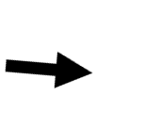



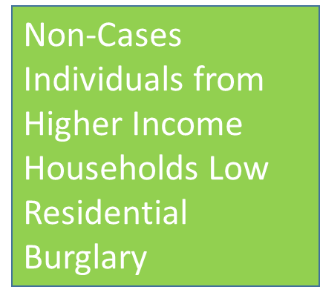
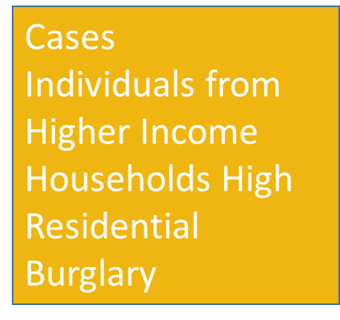
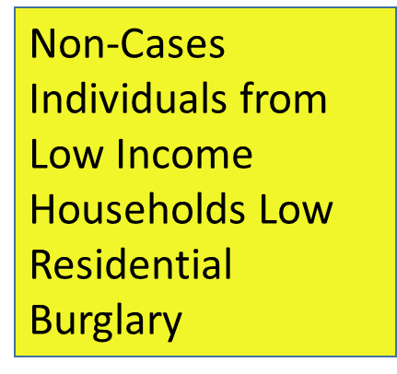
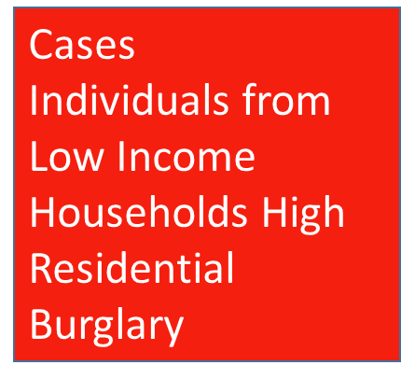


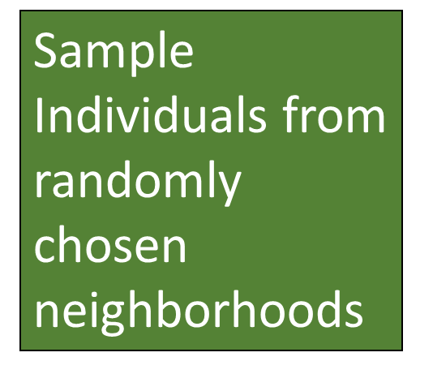

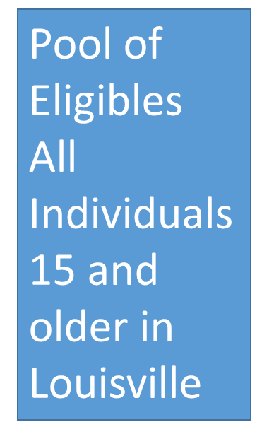

Conclusion
Ultimately, the literature has found that offenders live in close proximity to their targets and that patterns of offending are related to the distance between an offenders residence and their targets (Wright & Decker, 1994; Bernasco & Luykx, 2003; Bernasco & Nieuwbeerta, 2005; Markson, Woodhams, & Bond, 2010; Daele & Bernasco, 2012; Tonkin, Santtila, & Bull, 2012; Haginoya, 2014). The routine activities of the offender are is demonstrated by the distance from the offender’s home to their target and is related to their offending pattern (Markson, Woodhams, & Bond, 2010; Daele & Bernasco, 2012; Tonkin, Santtila, & Bull, 2012; Haginoya, 2014). The literature also found that offenders select targets according to a rational choice analysis, given a bounded rationality (Wright & Decker, 1994; Bernasco & Luykx, 2003; Kyung-Hoon & Joong –Yeon, 2008). Being a burglary victim increases in risk when socioeconomic factors, such as living near the central business district, the average number of dwellings, the percentage of the population in multifamily homes, and the percentage of ethnic heterogeneity is high in an area, is present (Cohen & Cantor, 1981; Wright & Decker, 1994; Bernasco & Luykx, 2003; Bernasco & Nieuwbeerta, 2005; Malczewski & Poetz, 2005). Individuals are at risk for victimization when they are young, have an income that is higher or lower than average, nonwhite, and often leave their residence unattended (Cohen & Cantor, 1981). Studies of guardianship against residential burglaries have include burglar alarms, gated communities and occupancy; the effectiveness of these prevention measures vary (Seungmug, 2010; D’Alessio, Eitle & Stolzenberg, 2012; Breetzke & Cohn, 2013; Lee & Wilson, 2013). An interesting finding in the literature is that when a residential burglary occurs then another is very like to occur in close proximity and that the risk of repeat or near repeat victimization decreases over time (Johnson et al., 2007; Johnson, Bowers, & Pease, 2012; Moreto, Piza, & Caplan, 2014; Yu & Maxfield, 2014).
The current study tests the relationship between economic status and residential burglary. A cluster sampling technique utilized neighborhoods in Louisville, Kentucky to distribute self-report surveys to a representative sample. The sample size of the study was 634 individuals ages 15 and older. The dependent variable was residential burglary which was measured using several questions asking about whether the respondent had ever committed a burglary and the number of residential burglaries the respondent has attempted. The main independent variable is economic status which was measured by asking about average household income and employment status. A cross-sectional designed was utilized in this study which enabled the researchers to gain descriptive information on the residential burglary problem. This study has demonstrated that policy makers should consider economic factors when approaching how to prevent residential burglaries.

References
Baskin, D., & Sommers, I. (2011). Solving residential burglaries in the United States: The impact of forensic evidence on case outcomes. International Journal Of Police Science & Management, 13(1), 70-86. doi:10.1350/ijps.2011.13.1.224
Bernasco, W., & Luykx, F. (2003). Effects of attractiveness, opportunity and accessibility to burglars on residential burglary rates of urban neighborhoods. Criminology, 41(3), 981-1001.
Bernasco, W., & Nieuwbeerta, P. (2005). How do residential burglars select target areas?: A new approach to the analysis of criminal location choice. British Journal Of Criminology, 45(3), 296-315. doi:10.1093/bjc/azhO70
Bradner, E., & Marsh, R. (2015, June 2). Acting TSA director reassigned after screeners failed tests to detect explosives, weapons. CNN. Retrieved from http://www.cnn.com/2015/06/01/politics/tsa-failed-undercover-airport-screening-tests/index.html
Breetzke, G. D., & Cohn, E. G. (2013). Burglary in gated communities: An empirical analysis using routine activities theory. International Criminal Justice Review (Sage Publications), 23(1), 56-74. doi:10.1177/1057567713476887
Cohen, I., Plecas, D., McCormick, A., & Peters, A. (2014). Eliminating crime: The 7 essential principles of police-based crime reduction. University of Fraser Valley: Len Garis.
Cohen, L. E., & Cantor, D. (1981). Residential burglary in the United States: Life-style and demographic factors associated with the probability of victimization. Journal Of Research In Crime & Delinquency, 18(1), 113-127.
Cohen, L. E., & Felson, M. (1979). Social change and crime rate trends: Routine activity approach. American Sociological Review, 44, 588-608.
Coupe, T., & Blake, L. (2006). Daylight and darkness targeting strategies and the risks of being seen at residential burglaries. Criminology, 44(2), 431-464. doi:10.1111/j.1745-9125.2006.00054.x
Homeland Security. (2015, September 23). Aviation security. Retrieved from https://www.dhs.gov/aviation-security
Kentucky Revised Statutes (KRS). (1980). KRS chapter 511. Retrieved from http://www.lrc.ky.gov/statutes/chapter.aspx?id=39377

